Table of Contents

1. Introduction:.............................................................................................2

2. Research and Planning:.............................................................................2

3. Choice of Framework and Technologies: ..................................................3

3.1. HTML5:...............................................................................................3

3.2. CSS……………………….............................................................................4

3.3. Javascript:……….......................................................................................4

3.4. GitHub:...................................................................................................5

4. Homepage:..............................................................................................5

4.1 Products………..:...................................................................................6

4.2 Cart:…………………................................................................................7

4.3 Link:……………….................................................................................8

4.4 References:…………….........................................................................9

**Introduction:**

Get fit website is an interactive website that provide users with the opportunity to purchase fits equipment.

In our world that is driven with tech today, the idea of going to physical shop to search for fits equipment to buy has gone into extinction and everybody wants their presence known online now, so it’s easier for potential customers who are everywhere on the internet to reach you via an online platform like get fit website.

The get fit website other than potential customers contacting you, also give opportunities to as many as possible to read about all the equipment on the website.

**Research and planning:**

The get fit website is created for users who will want to contact us for some of our services, a lot of people may be rendering the same services as ours but having access to all our information via the get fit website makes life easier for our customers and potential customers. To start with its development HTML5, CSS and Javascript was used. To create a web application that is both functional on a desktop and a mobile device all CSS responsive rules was observed during the development.

**Choice of technologies used:**

**HTML5:**

HTML 5 version was used in this web application; HTML 5 is a revision of the Hypertext Markup Language (HTML), the standard programming language for describing the contents and appearance of web pages.

HTML5 was developed to solve compatibility problems that affect the standard of HTML 4. HTML 5 provides one common interface to make loading element easier. For example, there is no need to install a flash plugin in HTML5 because the element will run by itself.

One of the design goals for HTML 5 is to support multimedia on mobile devices. New syntactic features were introduced to support this. Such as video, audio and canvas tags.

HTML 5 also introduces new features which can really change the way users interact with documents including:

New parsing rules for enhanced flexibility

New attributes

Elimination of outmoded or redundant attributes

Drag and drop capabilities from one HTML5 document to another

Offline editing

Messaging enhancements

Detailed rules for parsing

MIME and protocol handler registration

A common standard for storing data in SQL databases (Web SQL)

Having considered all these awesome features in HTML 5 it was used to build the layout of the web pages of this get fit website.

**CSS:**

Cascading style sheet (CSS) is a style sheet language used to describe the presentation of document written in HTML or XML (including XML dialects like SVG, MathML or XHTML). CSS describes how elements should be rendered on screen, on paper, in speech, or on other media.

CSS is among the core languages of the open web and is standardized across web browsers according to W3C specifications. Previously, the development of various part of CSS specification was done synchronously, which allowed the versioning of the latest recommendations. After CSS 2.1, the scope of the specifications increased significantly and the progress on different CSS modules started to differ so much, that it became more effective to develop and release recommendations separately per module.

 Instead of versioning the CSS specification, W3C now periodically takes a snapshot of the latest stable state of the CSS specification and individual modules progress. CSS modules now have version numbers, or levels, such as CSS Color Module Level 5

Seeing all these awesome improvements in CSS, was used on the styling and beautifying of get fit website and all the rules needed for a responsive website was thoroughly observed.

**Javascript:**

Javascript is a scripting language that allows you to implement complex features on web pages – every time a web page does more than just sit there and display static information for you to look at displaying timely content updates, interactive maps, animated 2D/3D graphics, scrolling video jukeboxes, etc.

You can bet that Javascript is most likely involved. It is the third layer of the layer cake of standard web technologies.

Javascript is a scripting language that enables you to create dynamically updating content, control multimedia, animate images, and pretty much everything else.

Hence Javascript was used to make get fit website interactive.

**GitHub:**

GitHub is a code hosting platform for version control and collaboration. It allows you and others work together on projects from anywhere.

You can also upload (push) your code on GitHub for other use. In this case I pushed the code to enable you access the code from your end.

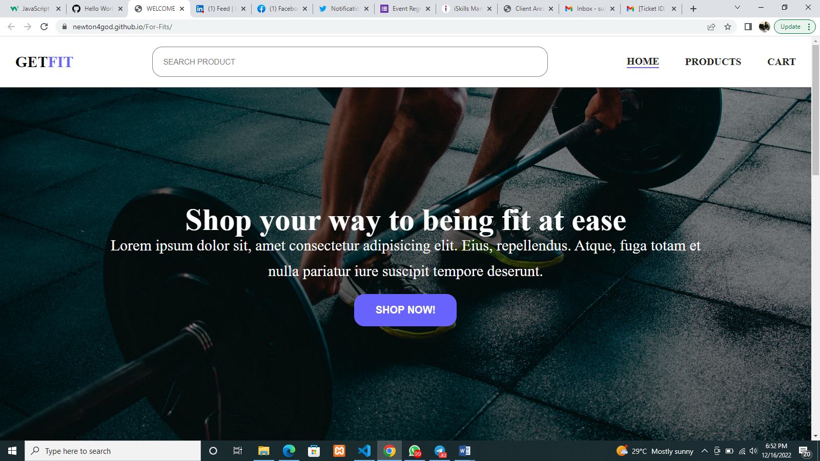

The home page introduces the user and display other pages, to help the users navigate around the web pages.

The home page also, is the first page that will open when you visit the website, hence I have “Shop your way to being fit at ease” on it to welcome my users, it also contains a call to action button to help my users if they decide to purchase any of our items.

The homepage also contains a search bar where users can easily search for the product that is not displayed on my products page, which make it easier for the client to easily search for any product even before getting to the products page.

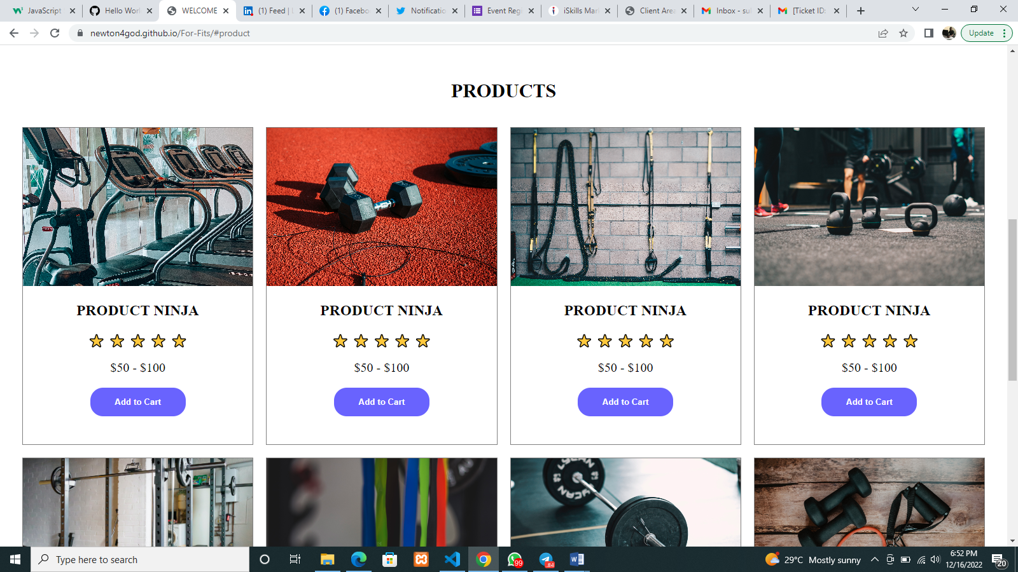

The products page contains some of our products display perfectly to help our users with decision. A user can easily scroll through to see our products and may be a good way to start with decision, and also our users can feed their eyes with beautifully placed fit equipment.

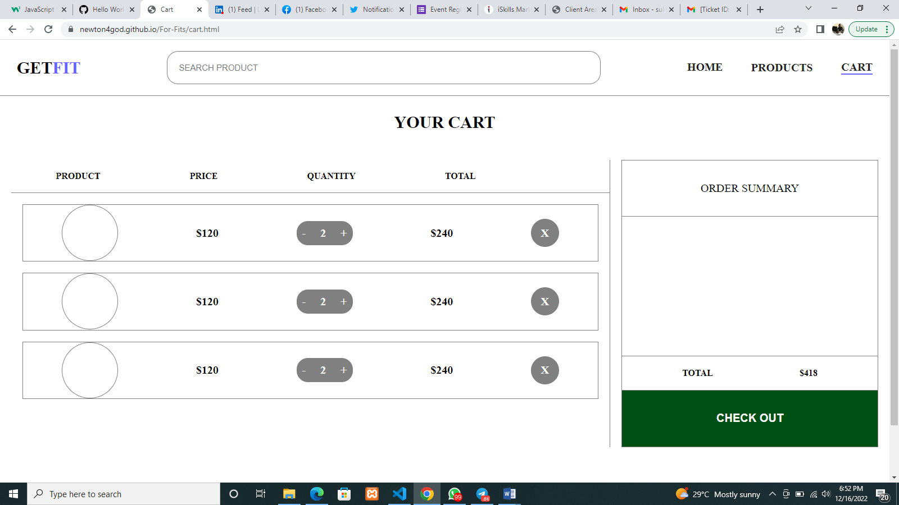

Our cart page provides an access to select the number of equipment that our users decide to purchase. The user doesn’t stress much as the product images are placed side by side with the price, quantity and total, to sum the amount of products selected. This page also carries the checkout button which mean you can pay immediately after you finish shopping your fit equipment.

**Link:** [**https://github.com/Neduthegoat/Get-Fits**](https://github.com/Neduthegoat/Get-Fits)

**References:**

<https://www.techtarget.com/whatis/definition/HTML5#:~:text=HTML%205%20is%20a%20revision,affect%20the%20current%20standard%2C%20HTML4>.

<https://developer.mozilla.org/en-US/docs/Learn/JavaScript/First_steps/What_is_JavaScript#:~:text=JavaScript%20is%20a%20scripting%20language,few%20lines%20of%20JavaScript%20code>.)

<https://developer.mozilla.org/en-US/docs/Web/CSS#:~:text=CSS%20(Cascading%20Style%20Sheets)%20is,animations%20and%20other%20decorative%20features>.